Level 2 - Module 1 Homework

Please fill this out on your computer so that you can upload the file for review. Feel free to edit, add or delete.
Please save it with your name in the file name. For example: Joan Orr Level2 Module1.doc

Exercise #1: Wishlist Items (list 3-5 items that you want to work on)

Exercise #2: Goals in Education Practice Activity
Answer the questions for 2 or more of the items

Wishlist Item # 1
- What will my learner do?
- What movements will I see?
- Why this is important?

Wishlist Item # 2
- What will my learner do?
- What movements will I see?
- Why this is important?

Wishlist Item # 3
- What will my learner do?
- What movements will I see?
- Why this is important?

Wishlist Item # 4
- What will my learner do?
- What movements will I see?
- Why this is important?

Wishlist Item # 5
- What will my learner do?
- What movements will I see?
- Why this is important?

Exercise #3: Undercover Boss Video

List some of the corrections you observed:

Turn these into statements phrased in the positive (what the learner is TO DO):

List one or two places where instructions were clumped:

List the component teachable parts that make up the clumps:

Identify the most important parts of the behavior:

Turn these into 3 tag points (fill in the Woof Planner – see next page). You can type in the text boxes.

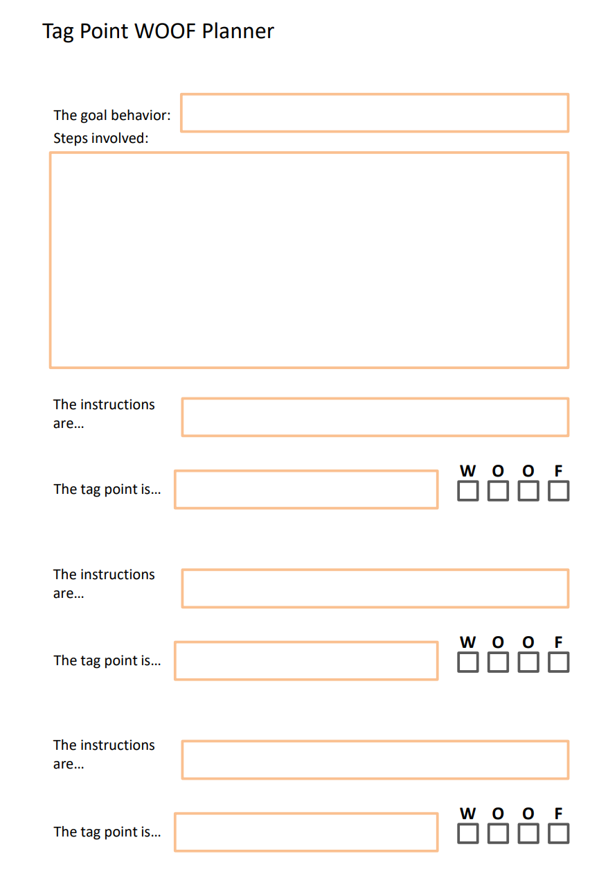

Exercise 4: TAGteach Tools and Session Review

Check off the strategies you see being used in each video

Title of Video | Dog Parkour |  | Paper in Lines
Management (Arrange antecedents)
Demonstration
Point of Success
Personalize the tag point
Teacher tags self
Learner tags teacher
Peer tagging
Targeting
Capturing
Three try rule
End on a high note

