Level 2 - Module 2 Homework

Please fill this out on your computer so that you can upload the file for review. Feel free to edit, add or delete.
Please save it with your name in the file name. For example: Joan Orr Level2 Module1.doc

Exercise #1: Ballet Troubles
List some of the corrections and turn them into positively phrased instructions
- Correction:
Positive phrasing:
- Correction:
Positive phrasing:
- Correction:
Positive phrasing:
Create tag points that would eliminate physical prompting/touching

- The tag point is…
- The tag point is…
- The tag point is…

Exercise #2: Wishlist Tag Points
Choose one item from your wishlist.
List the component parts:
Describe these in terms of body movements

Create 2 or 3 tag points that address the most important aspects

Use the WOOF Planner (on next page) to record your tag points and evaluate them against the WOOF criteria.
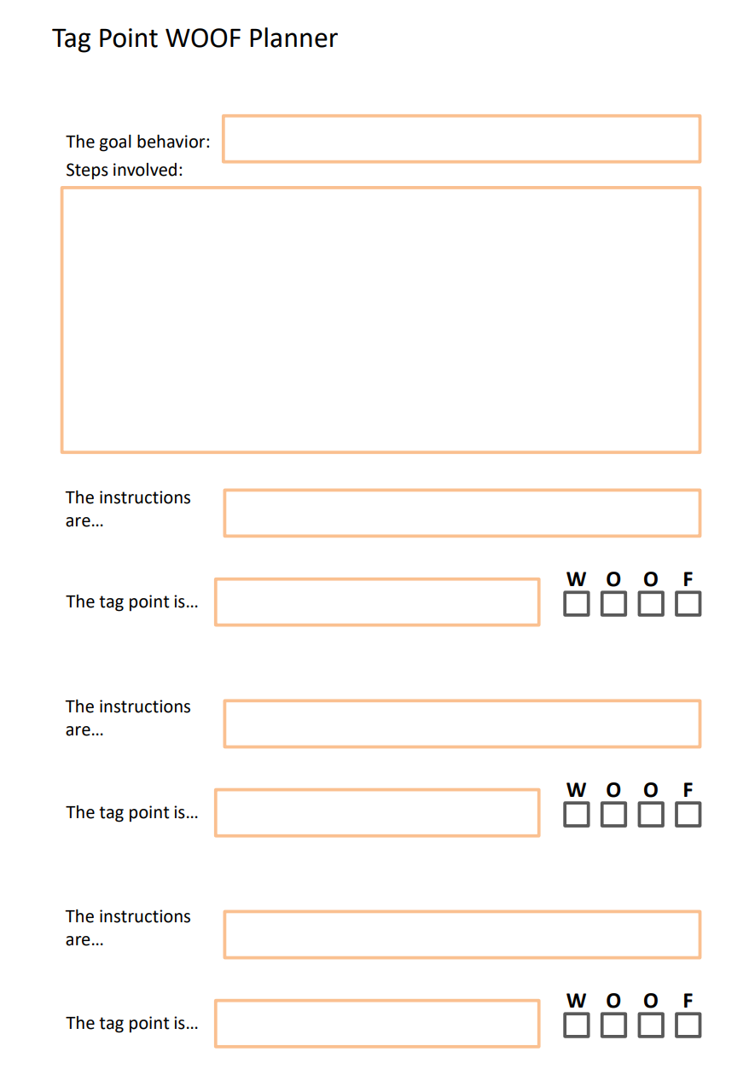

Exercise 3: Multitasking Results

Multitasking
Record your times and number of errors for the 2 tasks. If anyone else around you wants to do it too, you can put their data in as well.

 | Two Sequential Tasks |  | Two Simultaneous Tasks
 | Time to Complete | # Errors | Time to Complete | # Errors

Multinagging Video

How many things did Anne need to remember before her next turn?

How many times did you need to watch the video to get them all?

